PRINT TITLE | PAPER (IMAGE) SIZE  CM | IMAGE
B STAGE  Ed. 290 | 68 x 96.5  (55.2 x 83.8) | 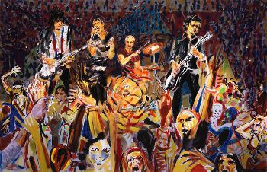
SKULLS ON STAGE  Ed. 290 | 73 x 96.5  (29 x 38) | 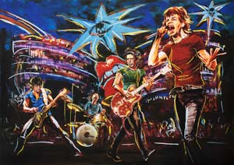
JOHN BELUSHI  Ed. 290 | 72.4 x 52.3  (72.4 x 52.3) | 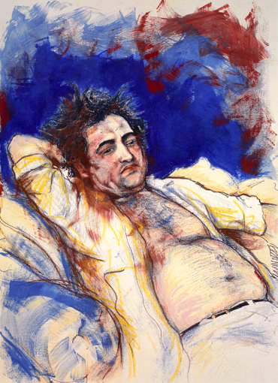
BIGGER BANG  COLLECTORS EDITION  Ed. 118 | 96.5 X 144.3 | 
BIGGER BANG  BLUE  Ed. 290 | 66 x 89  (56.2 X 83.6) | 
BIGGER BANG  RED  Ed. 290 | 66 x 89  (56.2 X 83.6) | 
BLUE CHARLIE  Ed. 275 | 67.5 x 51  (60.5 x 45.5) | 
CHARLIE & KEITH EXERCISING  Ed. 275 | 54 x 63.5  (36.3 x 48.6) | 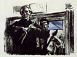
CHARLIE & RONNIE AT SANDYMOUNT  Ed. 275 | 54 x 63.5  (35.8 x 48.8) | 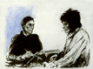
CHARLIE WITH DRUMS  Ed. 120  Etching | 59.5 x 48.4  (38.4 x 29.2) | 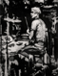
CONVERSATION PIECE (Canvas)  Ed. 118 | 71.75 x 110.5  (62.2 x 100.33) | 
DRYPOINT  BILL WYMAN  Ed. 150 | (50 x 40) | 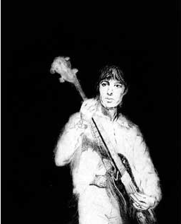
DRYPOINT  CHARLIE WATTS  Ed. 150 | (50 x 40) | 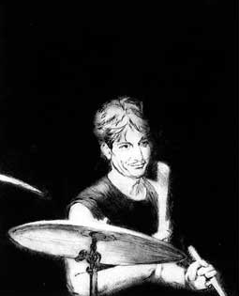
DRYPOINT  MICK JAGGER  Ed. 150 | (50 x 40) | 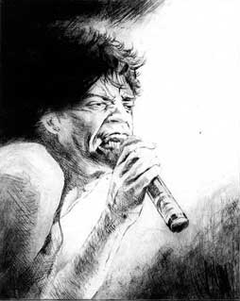
FACES – WE’LL MEET AGAIN  Ed. 250 | 108 X 80 | 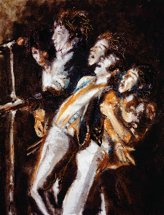
FAR EAST MAN  Ed. 290 | 59.2 x 45.3  (41 x 29.6) | 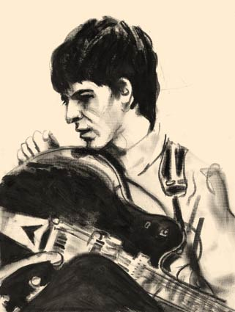
FLAT BED ‘75  Ed. 290 | 76.2 x 92.7  (60.3 x 80) | 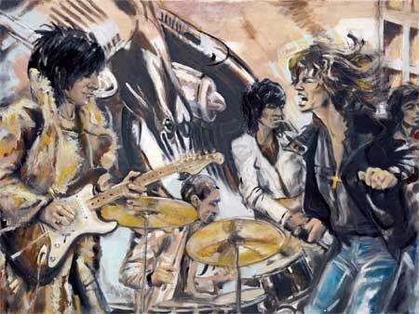
FLAT BED ‘75  30 Year Anniversary  (Canvas) Ed. 118 | 72.4 x 98.4 | 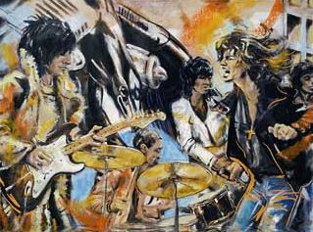
FLORIDA  PANTHER  Ed. 295 | 62.5 x 46.8  (47.6 x 33.6) | 
GENGHIS  Ed. 180 | 102.2 x 80.6  (80 x 62.2) | 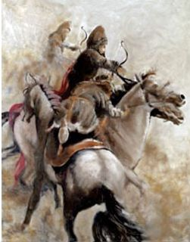
CARICATURE  COTTON CLUB CHARLIE  Ed. | 42 X 30 | 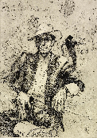
CARICATURE  GYPSY RONNIE  Ed. | 42 X 30 | 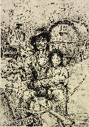
CARICATURE  PIRATE KEITH  Ed. | 42 X 30 | 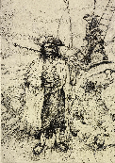
CARICATURE  SIR MICK  Ed. | 42 X 30 | 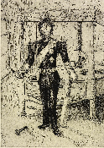

JAZZ SERIES  DUKE ELLINGTON  Ed. 250 | 53 x 72  (42 x 59.5) | 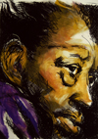
JAZZ SERIES  HOWLIN’ WOLF  Ed. 250 | 53 x 72  (42 x 59.5) | 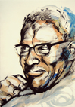
JAZZ SERIES  MILES DAVIS  Ed. 250 | 53 x 72  (42 x 59.5) | 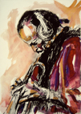
JAZZ SERIES  ROBBIE JOHNSON  Ed. 250 | 53 x 72  (42 x 59.5) | 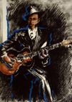
JIMI & ME AT THE SCENE CLUB N.Y.  Ed. 290 | 88.9 X 67.9 | 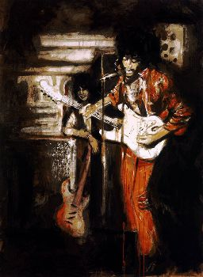
KEITH III  Ed. 250  SOLD OUT | (50.8 X 43.9) | 
KEITH MOON  (MAD HATTER)  Ed. 275 | 66.3 x 48.4  (51.3 x 35) | 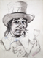
KEITH RICHARD IN MIRROR  Ed. 150  ASK FOR AVAILABILITY | (40.3 x 28.2) | 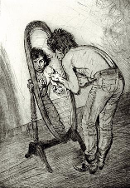
KEITH RICHARDS  “PENSIVE”  Ed. 600 | (53 x 80.8) | 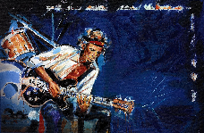
KEITH RICHARDS  “PENSIVE”  Collectors Edition  Ed. 250 | (80 x 116.6)
MANDRILL  Ed. 295 | 62.5 x 46.8  (47.6 x 33.6) | 
MARLEY  GET UP, STAND UP  RED  Ed. 195 | 84 x 74.5  (67.2 x 60.3) | 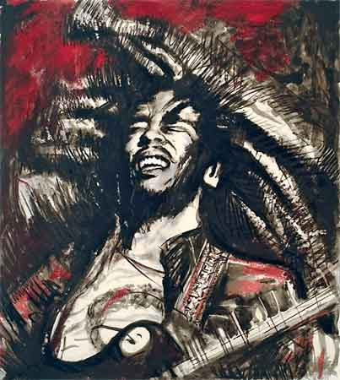
MARLEY  GET UP, STAND UP  BLUE  Ed. 195 | 84 x 74.5  (67.2 x 60.3) | 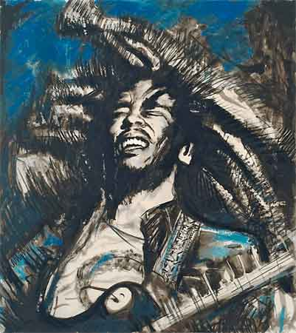
MARVIN GAYE  Ed. 250  ASK FOR AVAILABILITY | 78 x 58.5  (60.8 x 44.2) | 
MOSCOW FLYER  Ed. 180 | 102.2 x 80.6  (80 x 62.2) | 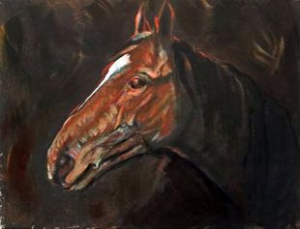
THE OTHERS SET  CHARLIE  Ed. 290 | 41.5 x 32  (34.3 x 26) | 
THE OTHERS SET  DARRYL  Ed. 290 | 41.5 x 32  (34.3 x 26) | 
THE OTHERS SET  MICK  Ed. 290 | 41.5 x 32  (34.3 x 26) | 
THE OTHERS SET  TOUCH (KEITH)  Ed. 290 | 41.5 x 32  (34.3 x 26) | 
ON STAGE SET  PLAY ON HANDS  Ed. 295 | 74.9 X 49.5 | 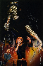
ON STAGE SET  TWANG  Ed. 295 | 74.9 X 49.5 | 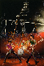
ON STAGE SET  WEAVING  Ed. 295 | 74.9 X 49.5 | 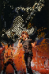
PRINT TITLE | PAPER (IMAGE) SIZE  CM | IMAGE
PORTFOLIO SET  IRISH LANDSCAPE  Ed. 175 | 31.75 x 52.7 | 
PORTFOLIO SET  JIMI HENDRIX  Ed. 175 | 50.2 x 37.5
PORTFOLIO SET  NUDE  Ed. 175 | 50.2 x 37.5 | 
PORTFOLIO SET  RHINO  Ed. 175 | 50.2 x 37.5 | 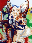
ROD  Ed. 290 | 64.3 x 52.5  (52.5 x 42.5) | 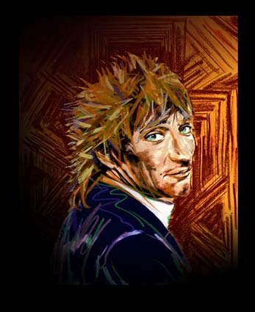

SLIDE ON THIS  Ed. 475 | 53.3 x 42 | 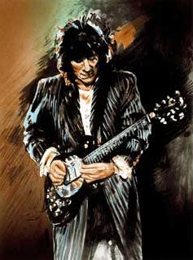
SOMEBODY ELSE  Ed. 600 | (24 x 17.7) | 
STUDY FOR KEITH  Ed. 120  Etching | 69.2 x 53  (52.2 x 39.5) | 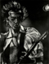
TUSK  Ed. 295 | 67 x 51.5  (52.7 x 41.3) | 
VOODOO CHARLIE  Ed. 295 | 86.5 x 67.3  (64.8 x 48.5) | 
VOODOO RONNIE  Ed. 295 | 86.5 x 67.3  (64.8 x 48.5) | 
WA WA WOOD  Ed. 250 | 119 X 80 | 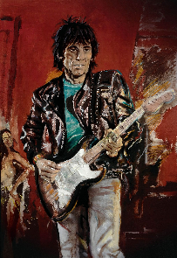
OUT OF CONTROL  Ed. 290  PAINT IT BLACK SET | 97 X 71.9 | 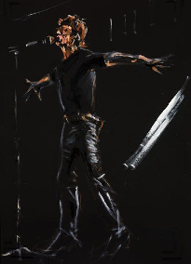
THE DOCTOR  Ed. 290  PAINT IT BLACK SET | 97 X 71.9 | 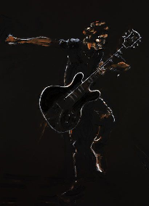
PRETTY BEAT UP  Ed. 290  PAINT IT BLACK SET | 71.9 X 97 | 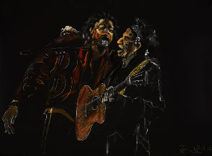
TIGHT SECTION  Ed. 290  PAINT IT BLACK SET | 97 X 71.9 | 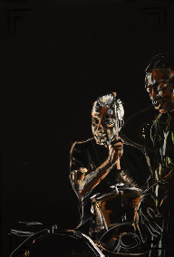
LISA FISHER  GIMME SHELTER  Ed. 290  PAINT IT BLACK SET | 97 X 71.9 | 

